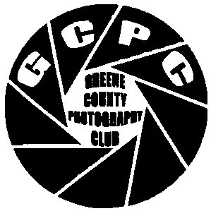
Greene County Photography Club

Volume 4 Newsletter
Issue 8 website: www.greenecountyphotoclub.org Member club of:
Aug. 2010 webmaster: Ruth Thornberg publicity: Beverly Yoskovich

President—Janice Morris Vice Pres—Jerry Hardy Secretary—Kathy Douglas Treasurer—Dave Brendel
724-627-6315 724-627-6757 724-852-4348 724-499-5148
cjmorris@windstream.net fjphardy@yahoo.com rittyrats@hotmail.com trainguy@windstream.net
Next meeting: 7:00 pm on Tuesday August 24th at the Waynesburg Bible Chapel.

July Winners
Pets
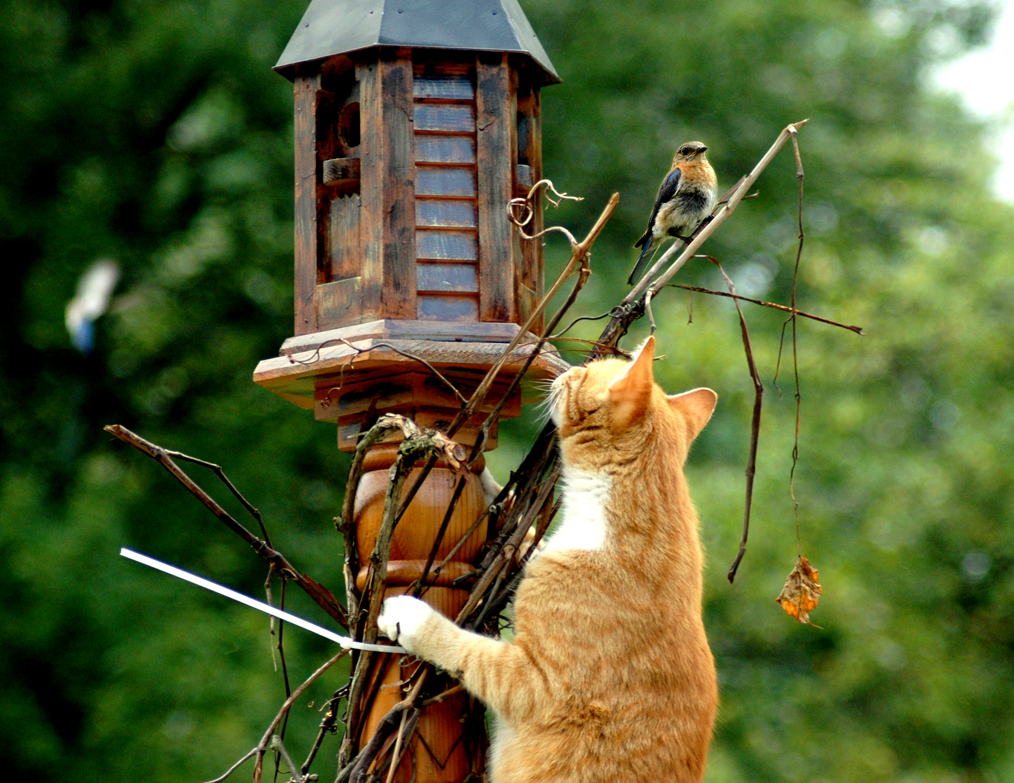
1st Place
Just Outta Reach
Beverly Yoskovich

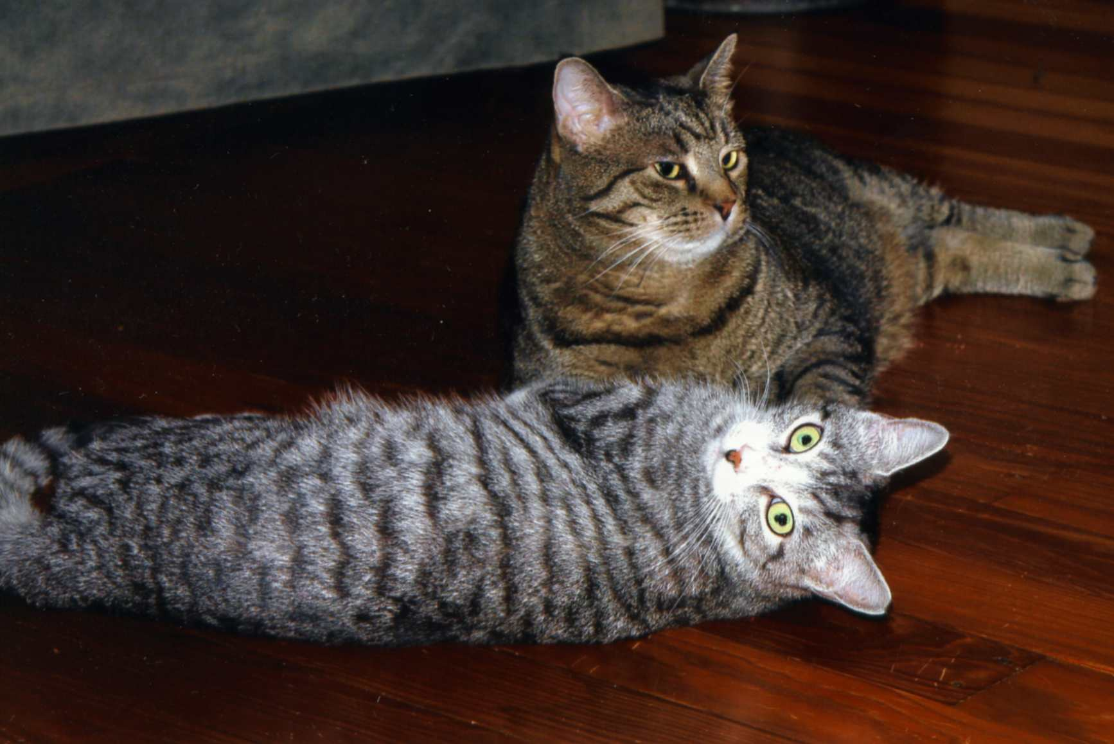
2nd Place
Cat Fight!
Jerry Hardy
July Meeting
As has become a regular expectation of our meetings, the July meeting was a great mix of competition, presentation, and fellowship. The monthly club competition subject was Pets, and everyone entered great pictures. With the largest number of monthly entries we’ve seen in a long while, competition for July’s winners was really stiff. Finally, the results had Andrew Corfont’s Granddog third, with Jerry Hardy’s Cat Fight second and Beverly Yoskovich’s Just Outta Reach as the outstanding first place winner.
Jerry used a slide presentation of his own making to discuss Using Filters—Then & Now. Having been the WCHS Camera Club advisor for 30 years, Jerry pointed out how one had used filters to enhance black and white photos and correct different light sources for color photos when all photos were from film. As for now, Jerry stressed that fewer filters are needed and most image enhancement can be accomplished with a polarizer, a haze filter, and a neutral density filter. According to Jerry, everyone should buy and learn to use a good polarizer. Do not buy a bargain one! Even more than that polarizer, Jerry stressed that everyone should get and attach a haze filter simply to protect the expensive lens on her/his camera. Briefly, Jerry discussed White Balance. He pointed out that every source of light is its own color, and your camera probably sees each differently. That explains why many indoor photos are yellowish, many gymnasium pictures are greenish, and most outdoor, daytime ones are “perfect.” Jerry stressed that we can correct all of those by learning to use the white balance settings on our cameras, and that we need to have a meeting presentation on doing just that.


3rd Place
Andrew’s Granddog
By Andrew Corfont

Upcoming Club Meeting Notes
Club competitions:
August—Series pix (a sequence of 3 or more)
Nov—Still Life
Presentations (tentatively):
Aug—Cows & Doors by Jim Butler
Sept—Picnic @ Butler’s (tentative)
Oct—Still life w/ members’ props

Library Exhibit
The Greene Co. Photography Club has again been invited to display at the Bowlby Library in September and October. All prints should be matted or framed, and no larger than 11x14 (including mat or frame). Some will be placed on easels and some will be hung.
All photos should include a tag with title, photographer’s name & a selling price (or say Not For Sale).The photos may be delivered to the Library (up to Sept. 4) or to Jerry (at the August 24th mtg).
Patrons and employees enjoy what's on display in our Gallery, so I would encourage members to submit work that hasn't been in the library in the past couple of years. As a club we can also consider doing a competition w/ this display (similar to last year's).
Do not miss this opportunity.

August Meeting
The next meeting will be at 7 pm on August 24th at the Waynesburg Bible Chapel. The club competition for August will be a series of photos. As a reminder, enter a series of 3 or more photos that illustrate some succession. Our presentation program for the evening will be Cows & Doors presented by Jim Butler.

Jacktown and Greene County Fairs
GCPC was well represented at both fairs as those visiting the fairs and taking in the photo entries saw our member’s photos had garnered most of the ribbons. Although there was not a convenient listing of club members’ photo entries and winnings for in this newsletter, we must congratulate everyone who entered, especially Phyllis Woods who submitted the Best of Show photo at the Greene County Fair.

Tourism Offer

GCPC member Andrew Corfont, who is also a member of Greene County Tourism, has asked GCPC members to submit photos for Tourism to use in an upcoming Greene County brochure. The project requires photos that highlight all of Greene County, and that brochure will be available to visitors and those who may be considering locating here. It will be similar to the brochure that highlights our covered bridges and the brochure that shows our Mail Pouch barns. The county has a lot to offer, and this will provide our members with another excellent opportunity to showcase their photography as well as serving as photo ambassadors for Greene County.
Gather your best Greene County photos or digital files and bring them to a club meeting or take them to the Greene County Tourism Office on Washington Street. You’ll be helping to “market” Greene County--Pennsylvania’s Best Kept Secret.

